KODMIC, Issuing Thirty-Year History
Korea Die & Mold Industry Cooperative (President: Kim Dong-Sub) issued 'Thirty-Year History of KODMIC' and celebrated the 30th anniversary of its foundation on Nov. 19.
The 'Thirty-Year History of KODMIC' summarizes the development process of the domestic die and mold industry and the organization from 1980 to 2010, and elaborates the foundation background, operation, main businesses and activities of KODMIC as well as the history and growth of the domestic die and mold industry and its industrial prospect with pictures.
It contains pictorial sections with main photos in each year and 'messages' left from veterans in the industry. Additionally, each photo section offers English version to allow overseas die and mold industries and related organizations to take a glance at the Korean die and mold industry.
In the 14th anniversary celebration of the Die & Mold's Day, held on Nov. 19, Kim Dong-Sub, President of KODMIC, dedicated the Thirty-Year History of KODMIC to Lee Yong-Gu, adviser and the first director of the organization.
Kim said “Since its foundation in 1980, the number of KODMIC members have increased to 530, and the Korean die and mold industry whose industrial base was vulnerable in early days has grown steadily. Now, KODMIC and the industry reach the advanced level of grown countries in terms of production and exports.” He additionally mentioned “With the issuance of Thirty-Year History of KODMIC, we will trail and rearrange the development process of KODMIC and the domestic die and mold industry, preserve our history with valuable historical materials, and make an opportunity to take a big leap forward to becoming a more advanced and better industry.”
KODMIC plans to distribute 2,000 issues of 30-Year History of KODMIC to die and mold companies, government organizations, institutes, and school libraries.

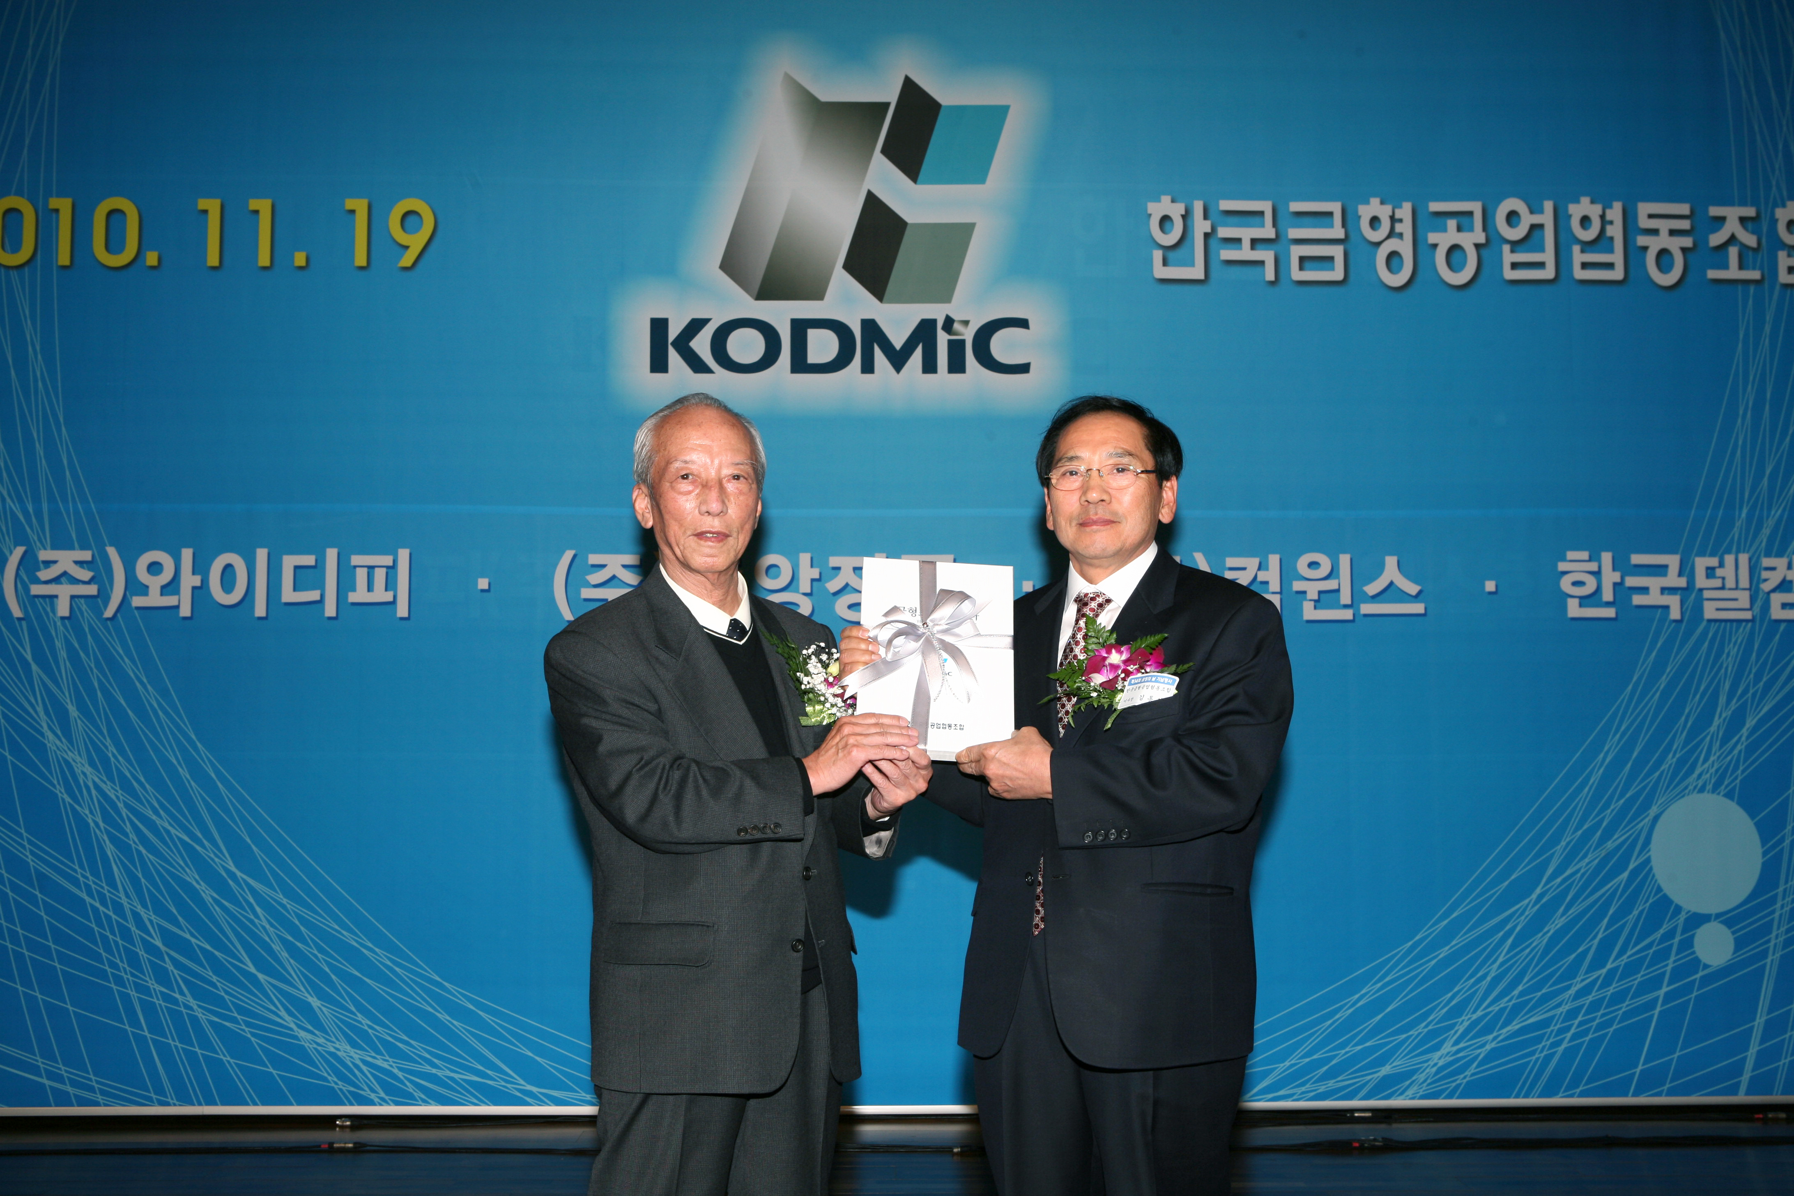
Deliver the Thiryt-Year History to Kim Young-Gu(Veteran of KODMIC)
at Die & Mold's Day

